your name here | your position here
5001 N. Oak Trafficway • Kansas City, MO 64118 • p) 816-414-3700 • w) mbts.edu • t)twitter.com/mbts

- Fill out the above signature with your information. Make sure to change the number to your own. Do not highlight the words to delete them, as it may change formatting. Instead, click at the end of the last word and backspace from there.
- Highlight the signature and copy it. Highlight like this:
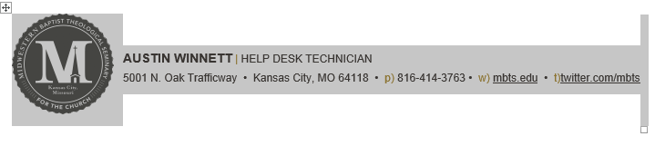

- In Outlook on your computer (not OWA online), start a new message.
- In the new message window, click the “Signature” buttons and then “Signatures…” from the dropdown.
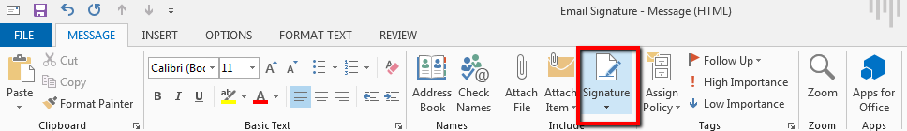
- 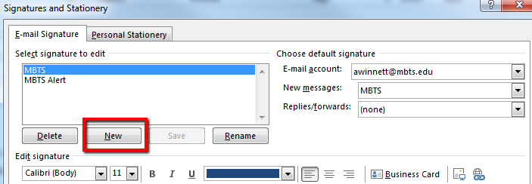
- 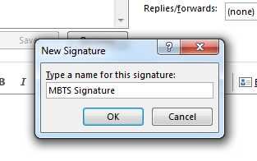

- Past the signature into this box.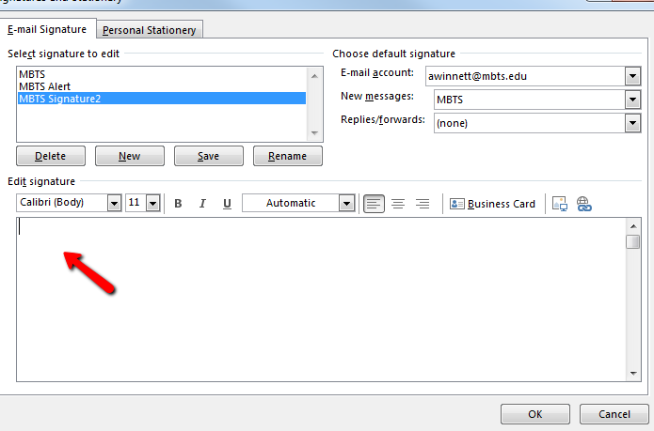

- Click the “Save Button”
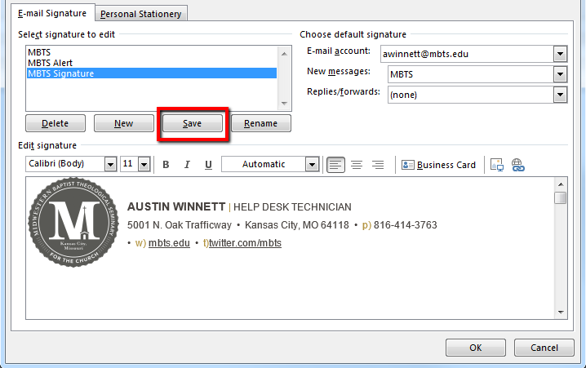

- Choose when you want to use the signature (preferably for New Messages and Replies/Forwards)
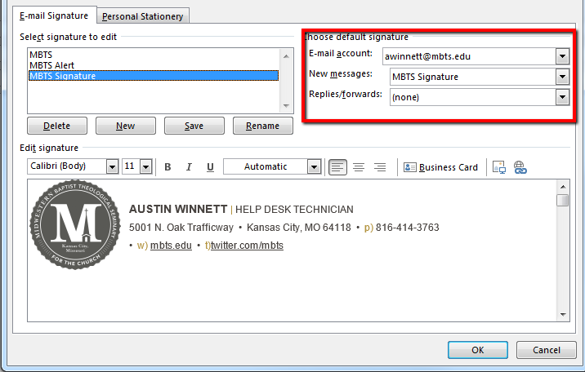

- Finally, click “OK”
- You can manually add your signature to an email by clicking the “Signatures” button and clicking the signature you want.

